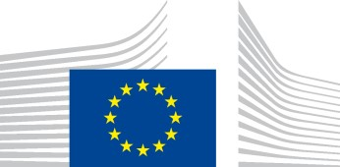
EUROPEAN
COMMISSION
Brussels, 13.10.2021
COM(2021) 660 final

COMMUNICATION FROM THE COMMISSION TO THE EUROPEAN
PARLIAMENT, THE EUROPEAN COUNCIL, THE COUNCIL, THE EUROPEAN
ECONOMIC AND SOCIAL COMMITTEE AND THE COMMITTEE OF THE REGIONS
Tackling rising energy prices: a toolbox for action and support

EN EN

Introduction
The European Union, like many other regions in the world, is currently facing a sharp spike in energy prices. This is a high concern for citizens, businesses, the European institutions and governments all over the EU.
Today’s spike is principally driven by increased global demand for energy at large and gas in particular, linked to the recovery. While energy price fluctuations have occurred in the past, today the EU emerges from the COVID-19 crisis. European households and companies face the prospect of higher energy bills at a time when many have been fragilised by loss of income from the pandemic. This can weigh on the recovery and its fairness and inclusiveness. It also risks undermining confidence and support in the energy transition required not just to avert disastrous climate change but also to reduce the EU vulnerability to fossil fuel price volatility.
The European Commission wants to help and support addressing the negative impact on households and businesses, as a priority. Having listened to Member States and the European Parliament, it has prepared this communication to enact and support appropriate measures to mitigate the impact of temporary energy price rises.
The EU’s policy framework already allows Member States to immediately take a series of targeted measures to protect vulnerable consumers and mitigate the impacts on industry. Indeed, most Member States have already announced measures to address the current situation. The present toolbox allows a co-ordinated approach to protect those most at risk. It is carefully calibrated to meet the goal of addressing the negative effects of sudden price hikes and ensure affordability without fragmenting the European single energy market or jeopardizing investments in the energy sector and the green transition.
While energy supply is not at immediate risk and the markets currently expect wholesale gas prices to stabilise at a lower level by April 2022, security of supply, gas storage levels and the proper functioning of the gas market need a particular monitoring ahead of the winter season. In addition to short term measures, this Communication provides an outlook onto coordinated measures the Commission considers to take over the medium-term to ensure a better preparedness to gas price fluctuations while reducing the EU’s dependence on fossil fuels.

Energy prices
Due to cheaper fuels, subdued demand and rapidly expanding renewable generation, wholesale energy prices fell sharply in 2019 and negative electricity prices became widespread in 2020. This downtrend has been abruptly reversed in the course of this year. Wholesale electricity prices have increased by 200% on a yearly basis. This in turn has driven up retail prices, but to a much lesser degree (+9% EU average until August 2021²).
2.1. What is causing the current spike?

The current electricity price increase is primarily due to global demand for gas soaring as economic recovery is picking up. Rising demand has not been matched by increasing supply with effects felt no only in the EU but also in other regions of the world. In addition, lower-than-expected gas volumes have been observed coming from Russia, tightening the market as the heating season approaches. Though it has fulfilled its long-term contracts with its European counterparts, Gazprom has offered little or no extra capacity to ease pressure on the EU gas market. Delayed infrastructure maintenance during the pandemic has also constrained gas supply.

As natural gas prices are a fundamental determinant of electricity prices in most of the EU, these dynamics underpin most of the current increase in the latter. In addition, electricity prices also increased because of seasonal weather conditions (low water and wind over summer). This has resulted in lower production of renewables in Europe.

The European carbon price has also risen sharply in 2021, albeit much less than the gas price. The effect of the gas price increase on the electricity price is nine times bigger than the effect of the carbon price increase. The carbon price rose by around EUR 30 per tonne of CO₂ this year, to the current level of around EUR 60 per tonne of CO₂. The price rose because of higher demand for allowances due to higher economic activity following COVID19 and expectations linked to the 2030 climate ambition but not only. High gas prices themselves contribute to an increasing carbon price since they lead to an increased use of coal for power generation and consequently higher demand for emission allowances. The ETS has in-built safeguards designed to address situations of excessive price fluctuations. While the conditions for triggering these measures are currently not met, the Commission will continue to monitor the evolution of the carbon price. It is important to note that the carbon price from the ETS provides a fundamental incentive to switch to cheaper renewable energy, more energy efficiency and performing buildings, and to low-carbon energy sources, thus contributing in the longer term to lower wholesale prices and reduced vulnerability to global shocks like the current one.

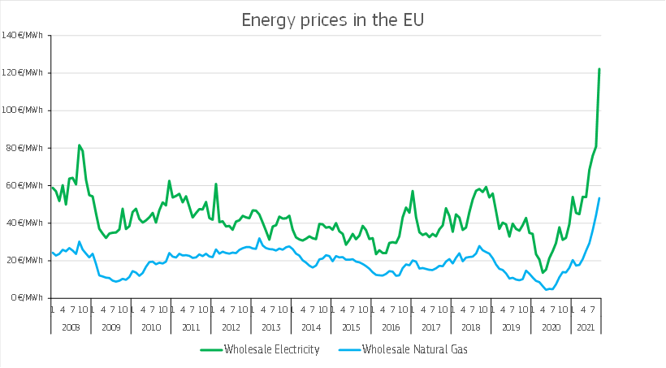

Natural gas still plays an important role in the EU energy mix. It currently represents around a quarter of the EU's overall energy consumption. Today, about 26% of that gas is used in the power generation sector (including in combined heat and power plants) and around 23% in industry. Most of the rest is used by households, and the service sector, mainly for heating and cooling. Although we have witnessed fuel switching towards gas and renewables in recent years, while the share of nuclear remained at around 25% of the electricity mix, surging gas prices have at least temporarily reversed this dynamic back towards coal in some Member States despite it generating a higher CO₂ intensity per MWh.

In 2019, the EU’s energy import dependency rate was 61% (56% in 2000). The high reliance on imports exposes the EU economy and key sectors to high fluctuations in the price of fossil fuels, which are traded on global markets. Gas prices are increasing globally, but more significantly in net importer regional markets like Asia and the EU. So far in 2021, prices tripled in EU and more than doubled in Asia while only doubling in the US.

2.2. The impact of high energy prices

Today’s high gas and electricity prices affect most Member States, although to different degrees and at different times. The link between wholesale and retail prices varies in each Member State and depends on the regulation and structure of retail prices and energy mix. The wholesale element typically makes up only a third of the final price, the rest being, transmission and distribution costs and taxes and levies. All else equal, where gas plays a greater role in the energy mix, retail prices were affected the most; where retail prices are more closely tied to the wholesale price in their contracts, the effects were felt earlier. Member States where long–term contracting is more common are likely to see a slower passthrough of the higher price increases over the coming weeks and months.

 | Gas & electricity price changes from in 2019-2021
 | BE BG CZ DK DE EE IE EL ES FR HR |  |  |  |  |  | IT | CY LV
Wholesale gas¹ | 592% | 159% 565% 554% | 559% 264% | 100% | 11% 370% 562% N/A |  | 406% | N/A 271%
Retail gas² | 38% | 23% 7% 51% | 5% -12% | 0% | 28% 4% 25% 5% |  | 14% | N/A 25%
Wholesale  electricity³ | 306% | 122% 227% 245% | 259% 151% | 343% | 121% 271% 281% 153% |  | 210% | N/A 153%
Retail electricity² | 21% | 8% 15% 16% | 5% 23% | 14% | 19% -8% 5% | 3% | -2% | -2% 4%
 | LT | LU⁴ HU MT | NL AT | PL | PT RO SI | SK | FI | SE | EU⁵
Wholesale gas¹ | 283% | 572% 410% N/A | 572% 462% | 504% | 0% -41% 52% | 37% | 289% | 7% | 429%
Retail gas² | 8% | 17% -6% N/A | 29% 19% | -2% | -4% 103% -1% | -8% | N/A | 6% | 14%
Wholesale  electricity³ | 154% | 259% 143% 171% 273% 258% |  | 83% | 271% 121% 151% 206% |  | 83% | 135% | 230%
Retail electricity² | 17% 7% -5% 0% -20% 14% 3% -4% 48% 5% 9% |  |  |  |  |  | 5% | 17% | 7%
- Source: Hubs data and EUROSTAT (latest available data). The latest available data is September 2021 for countries with a functioning hub (BE, BG, CZ, DK, DE, EE, ES, FR, IT, LV, LT, HU, NL, AT,PL, FI )
For the other Member States the data is from June 2021 (EUROSTAT) with the exception of SE (May 2021).
- Source: VAASAETT (September 2021).
- Source: ENTSO-E and multiple sources (September 2021).
- Luxembourg wholesale data is based on Germany data for electricity and the Netherlands data for gas. ⁵ Different proxies were used for estimating EU benchmarks based on the data availability

While the recent price hikes affect everyone, the energy poor and the low and lowermiddle-income households are most impacted because they spend significantly higher shares of their incomes on energy. Energy poverty has been closely monitored by the Commission. Based on the latest available data, in 2019, about 7% of the EU 27 population, i.e. 31 million people, were unable to keep their homes adequately warm, with significant differences between income groups and Member States. Moreover, 6% of the EU population lived in households with arrears on utility bills.

Social and distributional effects depend on current contracts, as well as on regulatory frameworks, including existing safeguards protecting in particular vulnerable and energypoor consumers. Such safeguards may include social and public policy measures, including social tariffs, and other means in line with the EU internal energy market, notably the Electricity Directive and the Gas Directive and guidance by the Commission¹⁰.
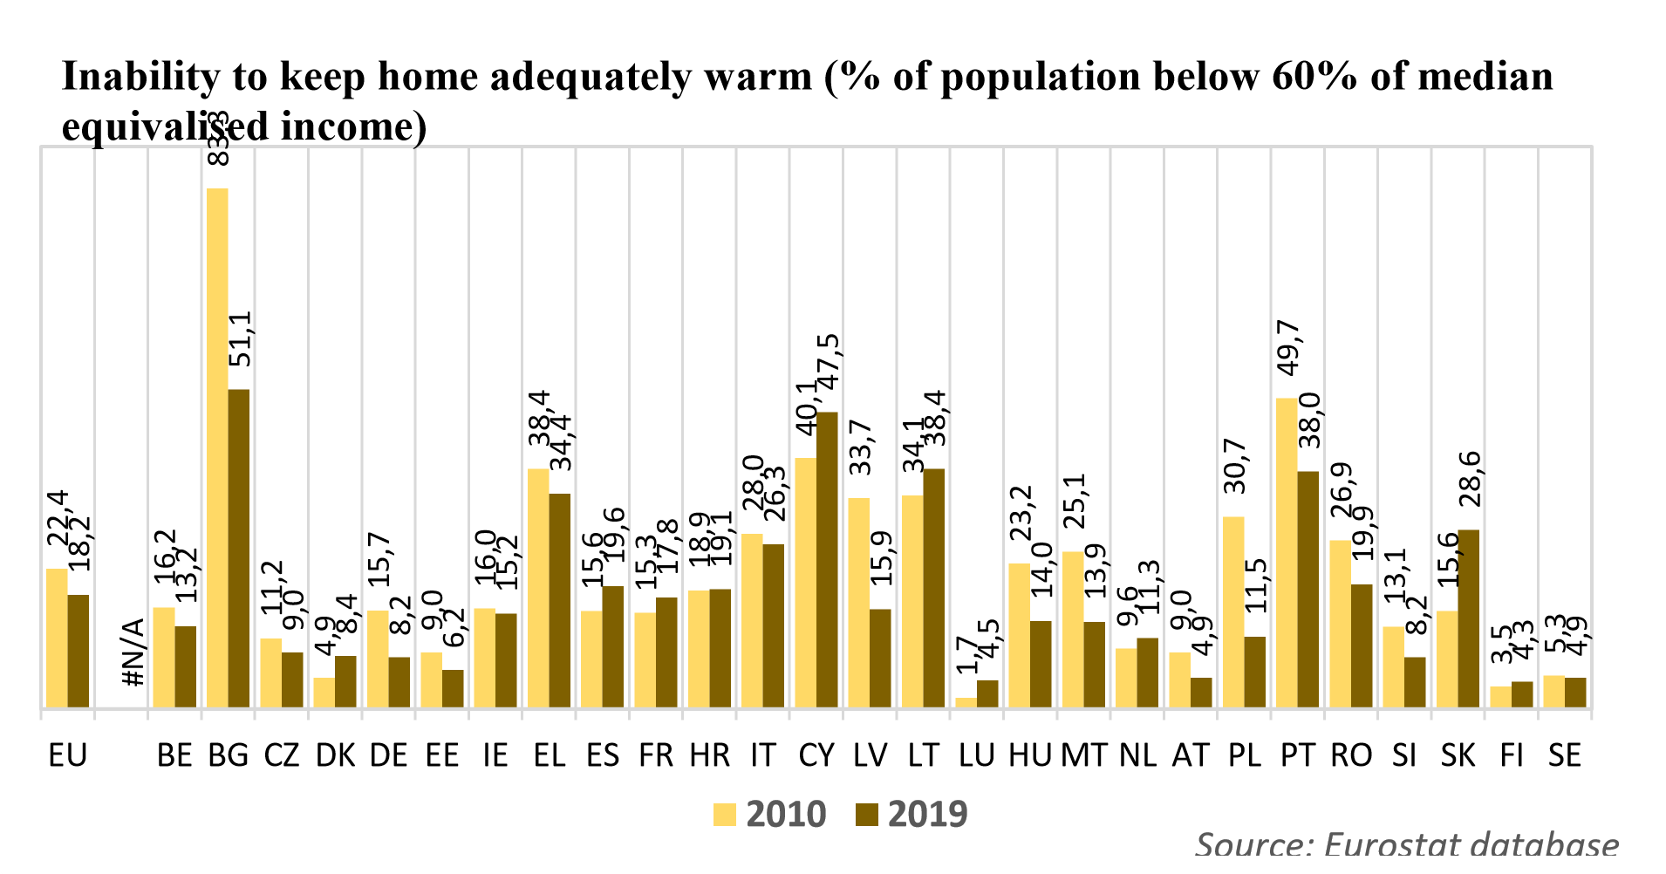
Rising gas and electricity prices can also have major repercussions on industry and on SMEs. The impact of high energy prices is felt unevenly across sectors, with the surge in prices hampering production in industrial sectors while impact on services is more limited. The current situation further exacerbates the post-COVID 19 liquidity issues of some businesses and of SMEs in particular, with different impacts across sectors.

High energy prices affect global and European supply chains with repercussions on production, employment and prices. Energy-intensive industries¹¹ are hit hard. The fertilisers sector illustrates this point. Highly dependent on natural gas as a raw material, production in the sector has become unprofitable and was therefore cut back substantially over the last weeks. This in turn affects the jobs in the sector. Furthermore, lower fertiliser production is expected to temporarily result in higher food prices or lower margins for the food industry.
An increase in energy prices is also having a significant and immediate impact on the transport and mobility sector, resulting in higher costs for drivers, passengers and for freight transport users.

Global high energy prices can also lead to lower raw materials and component supplies if production is cut down. This in turn momentarily affects various EU manufacturers who depend on those components and materials, with the notable example of magnesium and the EU car industry.

In terms of the macro economic impact, the sharp increase in energy prices has added to higher inflation. After several years, inflation has picked up markedly in the EU and many other advanced economies since the beginning of the year. This is mostly explained by

- See Commission Recommendation (EU) 2020/1563 of 14 October 2020 on energy poverty
- Energy costs account for a significant part of production costs in certain sub-sectors e.g. 71% of production costs in fertilisers, 40% in primary aluminium, 31% in zinc and 25% in flat glass.
transitory factors, including the return of some commodity prices from their historic low levels back to, or above, their pre-pandemic levels, and supply bottlenecks for certain goods. As these drivers are expected to be transitory, inflation is expected to ease again as of next year.
Overall, the EU economy is recovering faster than anticipated, and is set for continued growth in the short term. First-round effects on fiscal balances will depend on the extent to which fiscal revenues increase due to higher VAT collection on energy products and higher than expected revenues from the auction of emission allowances, on the one hand, and the magnitude of measures aimed at shielding end-users on the other, notably government transfer targeted at the vulnerable households or lowering of VAT.

2.3. Trends and expectations

Current market expectations on energy commodities indicate that the current price increases are likely to be temporary. Wholesale gas prices are likely to remain high over the winter months and fall from April 2022 onwards. The prices would remain, however, higher than the average of the past years.

While the current level of gas storage in Europe is tight it seems adequate to address supply risk in a winter similar to the previous one. Yet, the evolution of the weather during the winter season is a key variable to watch.

Use of storage capacity
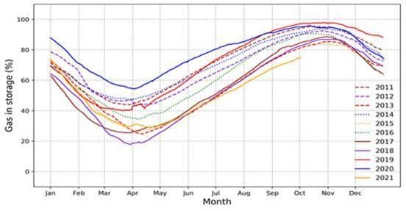
Source: Gas Infrastructure Europe

The EU Regulation governing the security of natural gas supply¹⁵ lays down the framework for EU emergency preparedness and resilience to gas disruptions. It provides for information exchange and regional cooperation and the development of contingency plans. The Regulation includes a solidarity mechanism that can be activated in extreme gas crisis situations. The Commission is regularly convening the gas security of supply network and constantly monitoring the situation at regional level.

In the medium term, price fluctuations may continue and future temporary sharp changes cannot be ruled out as global supply and demand may not always adjust smoothly due to a geopolitical, technological and economic factors.

The global electricity demand is set to grow by close to 5% in 2021 and 4% in 2022, driven by the global economic recovery. In Europe electricity demand is expected to increase in 2022 by almost 2%.

A toolbox of measures to help meet the challenge
The current price spike requires a rapid and coordinated response. The existing legal framework enables the EU and its Member States to take such action to address the effects of sudden price fluctuations.
The immediate response should prioritise tailored measures that can rapidly mitigate the effects on the vulnerable groups, can easily be adjusted when the situation improves for these groups and avoid interfering with market dynamics or dampening incentives for the transition to a decarbonised economy. In the medium term, the policy response should focus on making the EU more efficient in the use of energy, less dependent on fossil fuels and more resilient to energy price spikes, while providing affordable and clean energy to end-users.

3.1. Immediate measures to protect consumers and businesses

Twenty Member States have taken or are envisaging taking measures, often with a focus on mitigating the impact on the most vulnerable, the smaller businesses and energy intensive industries. This includes price caps and temporary tax breaks for vulnerable energy consumers, or vouchers and subsidies for consumers and businesses.

Such immediate measures could be partly financed from the revenue generated from the auctions of the EU ETS allowances, levies and taxes on energy prices, as well as through environmental taxes. In the current context, higher than expected ETS revenues can be used to finance the unforeseen needs for targeted social support. From 1 September 2020 to 30 August 2021, the revenues generated from the auctioning from EU ETS allowances¹⁶ amounted to EUR 26, 3 billion.

- Regulation (EU) 2017/1938 of the European Parliament and of the Council of 25 October 2017 concerning measures to safeguard the security of gas supply and repealing Regulation (EU) No 994/2010
- While ETS funds should primarily support further emission reductions through in particular investments into energy efficiency measures, the energy transition and innovation in clean technologies, Article 10(3)

3.1.1. Emergency income support and avoiding disconnections from the grid

Member States can make specific social payments to those most at risk to help them afford their energy bills in the short term or provide for support for energy efficiency improvements, while ensuring effective market functioning. This could be done as lump-sum payments, so as to maintain the incentive to reduce energy consumption and invest in energy savings.

In addition¹⁷, Member States can also put in place safeguards to avoid disconnections from the energy grid or can defer payments temporarily, where consumers face short-term difficulties in paying their bills. Several Member States introduced such measures at the beginning of the COVID-19 pandemic¹⁸ and these could now be extended.

Building on last year’s Recommendation on Energy poverty¹⁹, the Commission will call Member State representatives and energy regulators to engage on how to best protect, vulnerable consumers. This will enable Member States to exchange best practices and better focus measures to address energy poverty – in step with related EU policies such as energy efficiency and the renovation wave.

Member States could:
- Provide time limited compensation measures and direct support to energy-poor end-users including groups at risk, e.g. through vouchers or by covering parts of the energy bill, financed inter alia from the ETS revenues.
- Put in place and/or maintain safeguards to avoid disconnections from the energy grid or defer payments temporarily.
- Exchange best practices and coordinate measures through the Commission Energy poverty and vulnerable consumers coordination group.

3.1.2. Taxation

Taxes and levies provide revenue to compensate the most vulnerable households and address energy poverty, while providing incentives for investment into renewable energy sources and in support of the green transition.

of the ETS Directive (Directive 2009/29/EC) determines that Member States can use the ETS revenues to provide financial support in order to address social aspects in lower- and middle-income households.
- Regulated retail prices for energy poor and vulnerable households are allowed under EU legislation only in exceptional situations and under strict conditions. Regulated prices distort investment signals in generation and disempower consumers.
- Special COVID-19 measures to protect vulnerable consumers: National governments and energy regulators introduced suspended disconnections for non-payment of energy bills. In addition to government measures, a number of energy companies across the EU adopted voluntary initiatives to support customers such as payment arrangements and no disconnection policy.
- Commission Recommendation (EU) 2020/1563 of 14 October 2020 on energy poverty
Taxes and levies on electricity and gas retail prices vary widely. On average, they account for 41% of household's electricity prices and 30-34% of industry electricity prices, and for 32% of households’ gas prices and 13-16% of industry gas prices. The EU Energy Taxation Directive and VAT Directive give some flexibility to Member States. The Energy Taxation Directive allows Member States to exempt or to apply a reduced rate on electricity, natural gas, coal and solid fuels used by households. Member States can give effect to these exemptions or reductions in the level of taxation directly, by means of a differentiated rate or by refunding all or parts of the amount of taxation. Reduced rates have to be targeted and avoid introducing distortions. Member States may decide to apply reduced VAT rates on energy products as long as they respect the minima laid down in the EU’s VAT Directive²³, and they consult the EU VAT Committee.
Some Member States use the additional tax revenue to provide lump sum compensations for vulnerable households. Others divert parts of revenues from environmental taxes to finance social protection systems. Member States in which levies for subsidies for renewable generation account for a significant share of the retail electricity price, may consider funding such policies with public revenues other than electricity bills. This would have the benefit of relieving vulnerable consumers from a significant part of their energy bill.

The proposal for a revised Energy Taxation Directive, tabled in July 2021, aims at modernizing energy taxation in the EU by aligning it with the EU’s climate objectives and ensuring social fairness. The revised directive would encourage investment in and use of renewable energy sources and introduce the possibility of targeted exemptions to support vulnerable and energy poor households, especially during the transition to a cleaner energy system.

Member States could:
- Reduce taxation rates for vulnerable populations, in a time limited and targeted way
- Consider shifting the financing of renewable support schemes away from levies to sources outside the electricity bill.

3.1.3. State Aid

Measures of a general nature, equally helping all energy consumers, do not constitute State aid. Such non-selective measures can e.g. take the form of reductions in taxes or levies, a reduced rate to the supply of natural gas, electricity or district heating. To the extent national interventions qualify as aid, they may be considered compatible with state aid rules if they meet certain requirements. For example, aid in the form of reductions in harmonised environmental taxes up to the minima set in the Energy Taxation Directive can be implemented by Member States without prior notification to the Commission.

More targeted support measures can be used to help undertakings or industries to adapt in a timely manner and fully participate in the energy transition. Compliance with state aid rules and international subsidy rules will ensure that such measures do not unduly distort competition or lead to a fragmentation of the internal market. Aid interventions should be technology neutral and not be discriminatory for undertakings in a comparable situation. They should also not undermine the efficiency of existing market-based mechanisms (including the EU ETS) be aligned with the general decarbonisation objectives and those contained in national energy and climate plans.

Long-term renewables power purchase agreements should be encouraged. They can provide benefits both to industrial electricity users and renewable power producers. They are longterm contracts where a producer and an electricity buyer, agree to buy and sell an amount of renewable electricity and an agreed price over a longer period of time. Such agreements provide certainty for the producer about a certain income whilst the user can benefit from a stable electricity price. The Commission will work with Member States to facilitate a wider market for decarbonised power purchase agreements beyond large businesses, including SMEs, for instance by aggregating end-user demand, by addressing relevant administrative barriers or by providing standard contract clauses. In the short term, flanking measures such as match-making, standard contracts and de-risking through InvestEU financial products can support the deployment of such agreements.

Member States could:
- Take measures reducing energy costs for all energy end-users.
- Provide aid to companies or industries to weather the crisis, in full compliance with the state aid framework, while using, as appropriate, the scope for flexibility provided for in the framework and encouraging transition away from fossil fuels.
- Facilitate a wider access to renewables power purchase agreements beyond large business, including SMEs, for instance by aggregating end-user demand in compliance with competition rules.
- Support power purchase agreements through flanking measures such as matchmaking, standard contracts and de-risking through InvestEU financial products.

3.1.4. Stepping up market surveillance

In the current context of high prices, it is more important than ever to anticipate risks to security of supply and ensure the transparency and integrity of the functioning of the markets, dispelling concerns of manipulative practices or abuses including with regards to current developments. This requires mobilising all the market monitoring and enforcement levers available to the Commission, in partnership with Member States.
The EU has a strong and robust instrument that allows to detect market manipulation, the Regulation on Wholesale Energy Market Integrity and Transparency (REMIT). REMIT sets the ground for increased market transparency and integrity, and ultimately protects the interests of companies and consumers.
In the public debate around the energy price spikes, a concern has emerged for possible distortions of competition by companies active in European gas markets. The Commission is currently investigating as a matter of priority all allegations of possible anti-competitive commercial conduct by companies producing and supplying natural gas to Europe. The Commission is closely cooperating in the framework of the European Competition Network
(ECN) with the national competition authorities of the Member States. The EU’s trade defence instruments can also be relevant to ensure open and fair competition between energy intensive companies in third countries and the ones located in the EU.

Questions have also emerged around the functioning of the European carbon market and the reasons for the carbon price increase. However, there is no evidence in recent market information that speculation is a major driver of the price in the carbon market. In midSeptember 2021, the reports of the European Securities and Markets Authority (ESMA) show that the majority of positions (over 90%) are held by entities with compliance obligations under the ETS, and banks, which play an important role in servicing the hedging needs of compliance companies. The participation of financial entities in the market increases liquidity, which reduces pressure on prices.

Fair price formation and integrity of the European carbon market is guaranteed by a robust oversight regime also applicable to other financial markets. The participation of financial entities in the carbon market should increase liquidity, thereby helping to reduce volatility and pressure on prices. To examine more closely patterns of trading behaviours and the potential need for targeted actions, the Commission will ask ESMA, for a first preliminary assessment by 15 November and task itto analyse, by early 2022, the trading of emission allowances. The Commission will consequently assess whether certain trading behaviours would require further regulatory actions.

The Commission will:

- Investigate indications for any possible anti-competitive behaviour in the energy market.
- | Ask ESMA to further enhance the monitoring of developments in the European carbon market.
- | Together with ACER and national authorities ensure REMIT is effectively enforced.

3.1.5. Engaging international partners

Given the global nature of the current price surge, international cooperation on the supply, transport and consumption of natural gas can help keeping natural gas prices in check. The Commission is in dialogue with the main natural gas producing and consuming countries to facilitate natural gas trade. This dialogue with our international partners aims at enhancing the liquidity and flexibility of the international gas market in order to ensure sufficient and competitive natural gas supplies.

The Commission will:

- Enhance its international energy outreach in order to ensure the transparency, liquidity and flexibility of international markets
- Present an international energy engagement strategy in early 2022 that will, inter alia, consider the actions necessary to ensure security and competitiveness of international energy markets throughout the ongoing energy transition.

3.2. Medium-term measures

The current, unexpected price rise, is casting a light on some unknowns in the clean energy transition underway at global level.
Learning lessons from the this crisis, the EU should consider measures that without having an immediate impact on the current situation, will strengthen preparedness for possible future price shocks, increase market integration and resilience, empower consumers, enhance access to affordable energy and reduce the dependence on volatile fossil fuels.
The EU will continue to develop measures to facilitate an energy system with high shares of renewable energies, including through adequate storage, cross-border interconnectors, baseload and flexible power generation, thus offsetting possible temporary supply shortages or surpluses.

3.2.1. Storage capacity and a resilient EU energy system

Recent events remind us that the resilience of the European energy system is increasingly important as the EU energy system integrates more decentralised renewable energy and fossil fuels are gradually phased out. The security of supply and risk preparedness arrangements must be fit for the clean energy transition.

The current gas market situation shows that the level of gas storage remains a relevant variable. Today, storage is not available in all EU Member States. In around half of the Member States the use of storage is supported by national obligations, such as strategic reserves used in case of emergency. A more integrated European approach could optimise the costs and benefits of gas storage across the EU territory to help cushion volatility in energy prices.

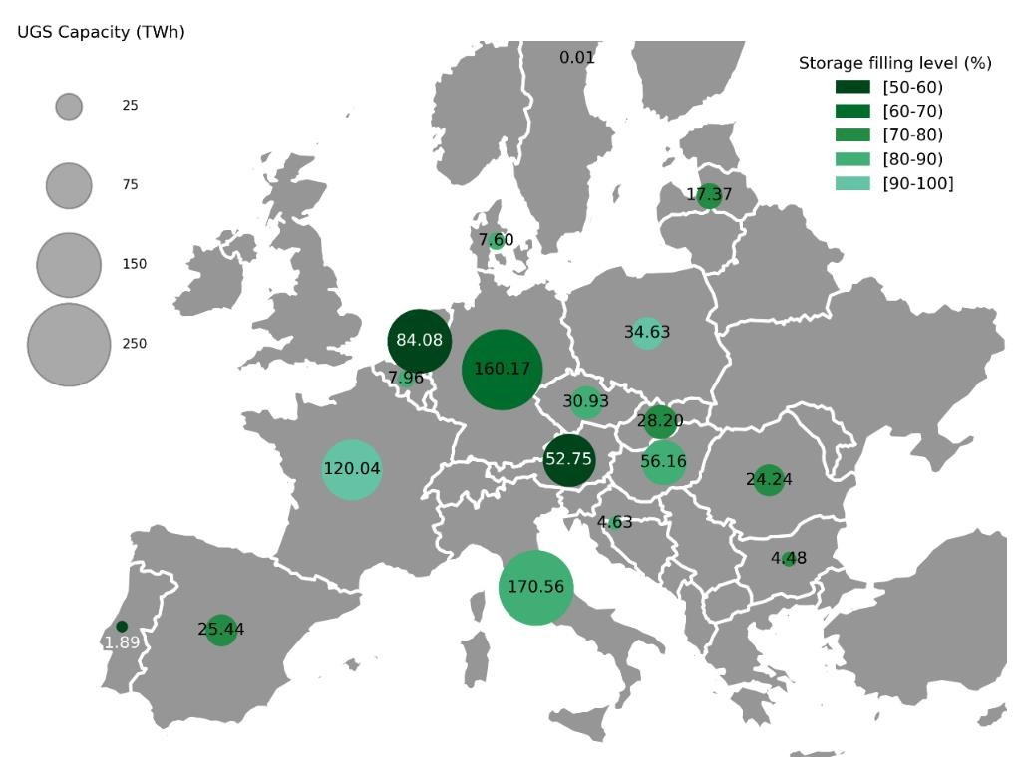
Source: developed by JRC based on data from Gas Infrastructure Europe (GIE)

The Commission plans to revise in December 2021 the gas security of supply regulation. In this context, the resilience of the EU gas market could be strengthened, for instance through provisions for an easier access to storage capacity across borders, including for renewable and low carbon gases. The Commission could explore the potential benefits of marked-based support mechanisms (e.g. involving auctions) to ensure that available gas storage capacities are optimally used. In this context, it is also key that Member States put in place the necessary technical, financial, and legal arrangements to supply gas across borders.
The Commission will also explore the possible benefits of joint procurement of reserve stocks of gas by regulated entities or national authorities to allow pooling forces and creating strategic reserves. Participation in the joint purchasing scheme would be voluntary and the scheme should be structured in a way so as not to interfere with the functioning of the internal energy market and respect competition rules.
Based on Regulation (EU) 2017/1938 concerning measures to safeguard the security of gas supply, the Commission intends to adopt shortly a delegated act setting up new cross-border regional gas risk groups. The risk groups will analyse risks for the next four years and advise Member States and the Commission on the measures to properly manage these risks. Particular attention will be paid to regions with unusual low storage. The risk groups will also assess the possibility of joint voluntary regional storage arrangements.

As announced in the Commission’s Communication of April 2021, the Commission will adopt a complementary Delegated act of the EU Taxonomy Regulation covering activities not yet covered in the EU Taxonomy Climate Delegated Act. This complementary Delegated Act will cover nuclear energy subject to and consistent with the results of the specific review process underway in accordance with the EU Taxonomy Regulation. This complementary Delegated Act will also cover natural gas and related technologies as transitional activity in as far as they fall within the limits of Article 10(2) of the EU Taxonomy Regulation. The merits of a sunset clause for transitional activities will be considered in this context. The Commission will consider proposing legislation to support the financing of certain economic activities, primarily in the energy sector, including gas, that contribute to reducing greenhouse gas emissions in a way that supports the transition towards climate neutrality, but are not eligible to be included in the Taxonomy.
Energy storage is increasingly key for the EU power sector and its sustainability. Both short to medium (batteries) and long-term storage (Power to X) options need to be exploited. Increasing electricity storage in particular supports integrating renewables into the system and smoothening peak demand. This could also lower electricity prices during peak times when generators using fossil fuels often set the price. Substantial investment need to be directed in this domain. The Commission will identify key EU actions to support the development of electricity storage as a key flexibility tool, ensuring a level playing field and adequate economic signals.

The EU electricity market is based on a marginal pricing method and the pay-as-clear market which means that everybody receives the same price for electricity at wholesale level. As gas-fired power plants are currently still frequently needed to meet electricity demand, the price of gas has an impact on the cost of producing electricity, with negative impacts as seen now. However, there is general consensus that the marginal pricing model is the most efficient for liberalised electricity markets and the most suited to foster effective electricity trading across Member States on the wholesale market. It is also tailor made to promote integration of renewable energies, which drive down prices thanks to their zero operational costs.

While there is of yet no clear evidence that alternative market framework would provide cheaper prices and better incentives, the Commission will task the Agency for the Cooperation of Energy Regulators (ACER) to assess benefits and drawbacks of the current wholesale electricity market design, among other its capacity to address situations of extreme price volatility in the gas markets and available measures to reduce such situations,while ensuring a cost effective transition towards a net zero energy system, and to propose recommendations which the Commission will assess for follow-up as appropriate. Meanwhile, the Commission will liaise with ACER to have a preliminary assessment of the situation in the electricity market on which it will report by mid- November.
Additionally, it is also important to adapt the resilience of the energy system to new evolving threats such as cyber threats or extreme weather events. The Commission will undertake actions by the end of 2022 to further improve the resilience of critical energy infrastructure in view of new evolving threats. These will include new rules on the cybersecurity of electricity fully harmonised with horizontal cybersecurity legislation, a
Commission’s recommendation towards a harmonised approach to identify critical energy infrastructure, exchange of information, and available options to finance the resilience of critical energy infrastructure. It will also include the creation of a European standing group of operators and authorities on the resilience of energy infrastructure.
The Commission will also study the potential of fully aligned regional, or EU-wide, retail markets. Evidence shows that greater cross-border alignment of rules and practices in the retail market boosts cross-border competition and helps keep prices under control. This work would build on two important ongoing pieces of work – Interoperability Implementing Acts. As was the case for wholesale electricity market coupling, such market alignment could initially be through cooperation between individual Member States before moving over time to a fully integrated internal energy market for consumers.

Innovation is an important component to ensure a resilient EU energy system. Europe is a leader on sustainable energy start-ups with innovative solutions ranging from deep geothermal energy to hydrogen. Member States and the EU should work together to facilitate that the innovative solutions are deployed.

The Commission will:

- Propose regulatory framework for the gas and hydrogen market by December 2021.
- Consider revising the security of supply regulation to ensure more effective functioning of gas storages across the Single Market and conclude the necessary solidarity arrangements.
- Adopt by November 2021 a regulation setting up new cross-border regional gas risk groups to analyse risks and advise Member States on the design of their national preventive and emergency action plans.
- Support the development of future-proof energy storage as a key flexibility tool, both for short to medium –term (for example demand-response and batteries) and long-term storage options (for example hydrogen).
- Explore the potential benefits and design of a voluntary joint procurement of reserve gas stocks, in line with energy market regulation and the EU competition rules.
- Adopt a rule book for cybersecurity for electricity.
- Task ACER to study the benefits and drawbacks of the existing electricity market design and propose recommendations for assessment by the Commission by April 2022.
- Study the potential of an initiative on developing fully aligned regional, or EU-wide, retail markets.

3.2.2. Supporting a just transition and protecting end users

As future energy price spikes cannot be ruled out, being able to support vulnerable consumers and enterprises will remain important. Tools and initiatives aiming at supporting a just transition will be of particular relevance.
By the end of the year, the Commission will propose a Council Recommendation providing further guidance to Member States on how best to address the social and labour aspects of the green transition to ensure its fairness. This initiative will indicate the accompanying policies needed to alleviate the possible adverse distributional impacts of the transition as well as to realise the opportunities the transition offers in terms of quality jobs and social co-benefits, such as affordable energy for all, while mitigating or compensating for adverse distributional impacts as needed.

The newly proposed Social Climate Fund would ensure a structural response to addressing energy and mobility poverty. It will provide Member States additional funding for building improvements, infrastructure development and direct income support that can support citizens throughout the initial phase of the green transition. With EUR 72.2 billion, the Fund specifically targets population groups (households, transport users, microenterprises) vulnerable to the challenges arising from the proposed extension of emission trading to sectors of building and road transport. The Fund can provide resources for Member States to grant temporary direct income support. With a proposal to draw on matching Member State funding, the Fund would mobilise EUR 144.4 billion.

EU consumers should enjoy a high degree of protection and empowerment to actively engage in the energy market. Concretely, consumers need to be better informed about their energy consumption, the possibilities to reduce their consumption and to switch the supplier to reduce costs. Consumers should have the possibility to contact consumer organisations, energy agencies and providers of energy efficiency services to receive feedback on their energy consumption behaviour over a defined period of time, and advice about how to reduce their energy consumption and bills. They should have the possibility to build their own renewable energy production and storage capacity at affordable prices and with a good return on investment, acting in their role as prosumers in the decentralised energy system. Special attention shall go to further development of energy communities, with a special focus on consumers living in rural areas.

An important part of the Commission’s December gas package will be enhanced consumer provisions, also for gas markets. The Commission is considering minimum requirements for contractual conditions, faster and free-of-charge switching, and an enhanced smart metering rollout to enable consumers to benefit from more and greener offers and better manage their consumption costs. A favourable framework for citizen energy communities on the gas market will enable consumers to buy renewable gases irrespective of their geographical location, as well as bring benefits for the local economy. This will help boost public acceptance of renewable gas projects and help mobilise private capital investments in renewable and low-carbon gases.

The market exit or failure of a supplier can have negative consequences for consumers – which they cannot control. Increasing energy prices can represent an undue pressure especially on small suppliers offering fixed price contracts. It is therefore necessary to facilitate access of all energy suppliers, including the small one, to financial markets so that they can hedge their contracts against future price developments. To remedy this EU legislation recognises that Member States may appoint a supplier of last resort. However, it is also important that this does not create a moral hazard – protecting suppliers from their commercial decisions at the cost of all consumers. In conjunction with measures to improve access to long-term markets for small suppliers, the Commission will clarify rules to protect consumers from the failure of individual suppliers and the operation of supplier of last resort schemes.
The Commission will:

- Propose, by December 2021, a Council Recommendation providing further guidance to Member States on how best to address the social and labour aspects of the green transition.

Member States could:

- Support consumer empowerment, providing consumers with information and offering options on how they can participate in the energy market, be better protected and in a stronger position in the energy supply chain.
- Appoint a supplier of last resort, in the event of market exit or failure of a supplier.
- Further boost the role of consumer in the energy market, by contributing to improving demand response, as well asby developing self-supply via individual renewable energy and energy community arrangements.

3.2.3. Stepping up investments in renewable energy and in energy efficiency

Wind and solar have close-to-zero variable costs. With more renewable energy in the power system, the most expensive fossil fuels will be pushed out of the market. In an increasing number of hours each year, the amount of renewable electricity in the system will allow to meet all demand and whole prices will be close to or at zero – or even negative. Overall, the predominant expert view it that all else equal, more renewables translate into lower wholesale market prices.

Looking beyond electricity markets, the overall cost of a number of renewable technologies has dramatically reduced over the past years. For instance, costs for electricity from utilityscale solar photovoltaics (PV) fell 85% between 2010 and 2020. Renewables are today already, in many sectors and uses, the cheapest form of energy, and consumers could in many cases reduce their energy bills by turning to renewable energy. This is true for industry and services, but also for households, that can for instance invest in solar photovoltaic panels, heat pumps, solar thermal equipment, or advanced biomass boilers – and by doing so reduce their electricity and heating bills.

For this, Member States should speed up permitting by reducing lengthy and complex permit procedures which are one of the biggest obstacles to development and deployment of clean energy infrastructure. Supporting self-consumption and renewable energy communities could also help households reap the benefits of cheaper renewables. Ramping up the production of equipment for renewables is another critical success factor for accelerating the deployment of renewables.

New technologies and digitalization provide new possibilities for demand side flexibility. The Commission will initiate work on a network code to remove regulatory barriers for the development of demand side flexibility at the beginning of 2022.

Energy efficiency lowers energy consumption and thus energy costs, but it requires investment. It addresses one of the root causes of energy poverty, notably through the improved energy performance of buildings and appliances. The Commission will also put forward a proposal to improve the energy performance of the European building stock. With certain renovation measures targeting social housing – and new rules for EU countries to measure and monitor figures for those that struggle to pay their energy bills – these building renovation rules will help to combat energy poverty.

At EU level, investments in the green transition have been stepped up. The 2021-2027 Multiannual Financial Framework reinforced by the NextGenerationEU are the main tools to bring about rapid recovery and a green and digital transition that will set our economy on a sustainable growth path. Under the Recovery and Resilience Facility, of the 22 plans approved by the Commission, EUR 177 billion have been allocated to climate-related investments.

Furthermore, bigger and more integrated markets with cross-border infrastructure provide a better deal for consumers. Complete and efficient physical interconnection with neighbouring markets, cross-border access for new suppliers will foster competition and ensure the supply of electricity at the most competitive price. Member States should continue promoting investment in trans-European networks to enhance competition and avoid curtailment, based on Projects of Common Interest. These include interconnectors, removing national bottlenecks, storage and smartening the transmission and distribution grids. The Commission will work with Member States on the necessary measures to achieve the 15% electricity interconnection target by 2030, in line with the European Council Conclusions of October 2014.

The Commission has recently proposed to review the Guidelines on State aid for Environmental Protection and Energy to enlarge the possibilities for Member States to grant financial support for climate protection and decarbonisation of the whole economy. The new rules, which are expected to enter into force next year, will reduce the recourse to fossil fuels, prevent stranded assets and make possible to introduce schemes to fund new technologies, such as storage and renewable hydrogen and facilitate funding for energy efficiency measures.

Member States should:

- Accelerate auctions for renewable energy and ensure the rapid and full implementation of relevant investments under the Recovery and Resilience Fund.
- Speed up permitting by reducing lengthy and complex permit procedures which are one of the biggest obstacles to development and deployment of clean energy infrastructure.
- Ramping up the production of equipment for renewables which is another critical success factor for accelerating the deployment of renewables.
- Step up investments on energy efficiency and in buildings performance, which lowers energy consumption and energy costs and eases pressure on energy markets.
- Step up investments in trans-European networks to avoid curtailment, based on Projects of Common Interest. These include interconnectors, removing national bottlenecks, storage and smartening the transmission and distribution grids.

The Commission will:

- Issue guidance in 2022 on accelerating permitting processes for renewable energies and continue working closely with national administrations to identify and exchange on good practice.
- Initiate work on the development of a network code for demand side flexibility at the beginning of 2022.
- Complete the revision of the Energy and Environmental State Aid Guidelines to facilitate the achievement of the European Green Deal at the least cost, facilitating energy efficiency and renewables investments.
- Continue assisting Member States in making the best use of the financial resources available in the EU budget and NextGenerationEU.

Conclusion
The measures described in this Communication aim to provide a response to the current energy price surge and will contribute to achieving a socially just and sustainable energy transition. The Commission will closely follow the situation over the coming months.

Member States can act and are already taking a number of measures linked to taxation, direct income support and other well targeted and time limited measures to provide short term relief to the problems the price surge creates for some. At the EU level, a number of additional measures on storage, market integration and energy communities can be done in the medium term to ensure more resilient energy markets, better prepared for volatility and the challenges of the transition. Advances in energy efficiency and measures to modernise the energy system will bring down energy bills in the longer term.

Europe’s energy, environmental and climate policy, funding available through various EU programmes as well as the Commissions recent ‘Fit for 55’ proposals are designed to create a sustainable energy sector for the long term. The European Union is firmly committed to the transition to climate neutrality and to decarbonising the energy system by substituting fossil fuels with renewable energy and consequently curtailing our dependence on energy imports.

Clear commitments to invest in climate neutral energy solutions across Member States will help reduce energy price volatility and imbalances in energy supply and demand brought about by movements in international fossil fuel prices, and other external factors. They are essential for keeping energy affordable for all consumers.

A successful green transition will lead the transformation not only towards clean energy, but also more energy efficiency and different use. The EU’s commitment to significantly reduce its greenhouse gas emissions and fossil fuels consumption is fully confirmed by recent events. Measures need to be accelerated, both on the regulatory and investment side. The clean energy transition is the best insurance against price shocks like the one the EU is facing today. It’s time to speed up.

Compared to the average price in 2019, prices at the beginning of October 2021 have increase by 166% for the benchmark EP5 (DE, ES, FR, NL) and Nordpool market (NO, DK, FI, SE, EE, LT, LV) ² VaasaETT (https://www.vaasaett.com/)
From January 2021 to September 2021, the ETS price has increased by about 30 EUR / tCO2, which translates into a cost increase of about 10 EUR / MWh for electricity produced from gas (assuming a 50% efficiency) and about 25 EUR / MWh for electricity produced from coal (assuming a 40% efficiency). This is clearly outweighed by the observed increase of the gas price of about 45 EUR / MWh over the same period, which translates into additional electricity production cost of about 90 EUR / MWh
Article 29a ETS Directive provides that if, for more than six consecutive months, the allowance price is more than three times the average price of allowances during the two preceding years on the European carbon market, the Commission shall immediately convene a Committee meeting with Member States in order to discuss potential measures.
Natural gas can be imported into the EU either through pipelines from its source or transported in the form of liquefied natural gas (LNG). The gas must be stored to balance fluctuations in daily and seasonal demand. It also secures the supply of gas in the event of supply disruptions or particularly high demand. The main advantage of stored gas is that it is available close to consumers and can be supplied without delay.
Oil (97%), coal (44%) and gas (90%)
During COVID-19, 8 Member States (of 21 where data is available) saw a year-on-year increase in the energy poverty rate in 2020, while 13 saw a decrease, including the 5 Member States with rates above 15% in 2019 (Bulgaria, Greece, Cyprus, Lithuania and Portugal)
Directive (EU) 2019/944 of the European Parliament and of the Council of 5 June 2019 on common rules for the internal market for electricity and amending Directive 2012/27/EU
Directive 2009/73/EC of the European Parliament and of the Council of 13 July 2009 concerning common rules for the internal market in natural gas and repealing Directive 2003/55/EC
The Dutch TTF Gas Futures index, currently at around 90 €MWh has a price around 50€MWh in April 2022.
Year-ahead: 42 EUR/MWh, two-year ahead: 35 EUR/MWh, three year ahead: 32 EUR/MWh
Current EU gas storage levels are slightly above 75%, below the 90% seen on average over the past 10 years. As of the 3th of October 2021.
Such taxes and levies notably include excise duties on energy products and electricity and value added tax (VAT), which are harmonised at EU level, but also other domestic environmental taxes and levies to finance renewable investments necessary for the green transition.
. Council Directive 2003/96/EC of 27 October 2003 restructuring the Community framework for the taxation of energy products and electricity
Council Directive 2006/112/EC of 28 November 2006 on the common system of value added tax ^{23.} The legal framework on VAT rates is currently under review in Council.
. In accordance with Block Exemption Regulations and State aid Guidelines, any state interventions should be set in a transparent, non-discriminatory manner, based on objective and proportionate criteria.
Commercial conduct implies that companies can determine independently their decisions, without being compelled to behave in a certain way by law.
The market is supervised by financial regulators of 27 Member States under the coordination of the European Securities and Markets Authority (ESMA).
COM/2020/823 final, Proposal for a Directive of the European Parliament and of the Council on measures for a high common level of cybersecurity across the Union, repealing Directive (EU) 2016/1148
https://ec.europa.eu/info/news/commission-publishes-report-barriers-eu-retail-energy-markets-2021-feb23_en
COM/2021/550 final. Communication from the Commission to the European Parliament, the European Economic and Social Committee and the Committee of the Regions 'Fit for 55': delivering the EU's 2030 Climate Target on the way to climate neutrality.
If certain non-flexible power plants have to continue producing despite negative prices.
It is for instance estimated that the increase in renewable electricity was responsible, ceteris paribus, for a 24% decrease of spot electricity prices in Germany over 2008-2015, and of 35% in Sweden over 20102015 (Hirth, 2018)
IRENA, Power Generation Costs in 2020
The expenditures reported for the RRF are Commission’s estimates based on the climate tracking figures published as part of the Commission’s analyses of the recovery and resilience plans. The amount reported covers the 22 national recovery and resilience plans assessed and approved by the Commission by 5 October. It will evolve as more plans are assessed.
https://ec.europa.eu/energy/topics/infrastructure/projects-common-interest_en
https://data.consilium.europa.eu/doc/document/ST-169-2014-INIT/en/pdf

